The court hierarchy in Queensland—TEACHER NOTES
Level year: Year 11 Worksheet number: 1.1.0
Curriculum context | Related worksheets
Legal Studies 2019 (General Senior Syllabus):
- Unit 1: Beyond reasonable doubt, Topic 1: Legal foundations and Topic 3: Criminal trial process

Queensland has a number of different courts and tribunals. Each court or tribunal has a unique jurisdiction.

Learning objective
Learners will:
- describe the court hierarchy in Queensland
- classify different types of legal matters
- explain the court hierarchy as it applies to trials.

Focus question
- What is the court hierarchy in Queensland?

Key concepts
- Appellate jurisdiction
- Civil law
- Criminal law
- Hierarchy
- Original jurisdiction

Further information
- Caxton Legal Centre Inc, The court system—queenslandlawhandbook.org.au/the-queensland-law-handbook/the-australian-legal-system/the-court-system/
- Lawrights, Appeals in the Queensland Court of Appeal: how to bring an appeal—legalpediaqld.org.au/index.php/Appeals_in_the_Queensland_Court_of_Appeal_-_how_to_bring_an_appeal#Grounds_of_appeal
- Legal Aid Queensland, Appeals in criminal law matters—legalaid.qld.gov.au/Find-legal-information/Criminal-justice/Criminal-court-process/Appeals-in-criminal-law-matters
- The Hon Justice McMurdo AC, Making your appeals more appealing— archive.sclqld.org.au/judgepub/2015/mcmurdo070315.pdf
- Queensland Courts, Courts—courts.qld.gov.au/courts
- Queensland Courts, The appeal process—courts.qld.gov.au/courts/court-of-appeal/the-appeal-process
- Queensland Government, Appealing a court decision—qld.gov.au/law/sentencing-prisons-and-probation/appealing-a-court-decision

The court hierarchy in Queensland—STUDENT TEXT

Our legal system has a range of courts and tribunals, including the Queensland Civil and Administrative Tribunal (QCAT), Magistrates Court, District Court and Supreme Court of Queensland. The High Court of Australia is the highest court in every state and territory.
Each court or tribunal has a different jurisdiction. This is decided by legislation. Some hear civil cases, some criminal cases, some both. (This is often referred to as a court’s original jurisdiction.)

Court or tribunal | Civil jurisdiction | Criminal jurisdiction
Supreme Court of Queensland | Disputes above $750,000 | Murder, manslaughter and drug trafficking
District Court of Queensland | Disputes $150,000 - $750,000 | Rape, armed robbery and grievous bodily harm
Magistrates Court of Queensland | Disputes below $150,000 | Traffic infringements, minor offences (shoplifting) and some serious offences (assault, fraud and drug possession)
Queensland Civil and Administrative Tribunal (QCAT) | Disputes about tenancy agreements, building, administrative decisions, consumer, debt below $25 000 and trees
A brief summary of the civil and criminal jurisdiction of the Queensland court system. Please note, this summary is not exhaustive.
Our courts are arranged in a hierarchy (shown on page 3). There are many reasons why a court hierarchy exists.
- The court hierarchy supports the appeal process. Appeals occur when one party asks for a decision to be reviewed by a higher court. For example, an appeal against a decision made by the District Court of Queensland would be heard by the Queensland Court of Appeal. The highest appellate court is the High Court of Australia. To have your case heard in this court, you need to apply and be granted special leave. To learn more about advocacy in special leave applications, read a speech by the Hon Justice Hayne AC QC.
- The hierarchy supports the doctrine of precedent, a fundamental principle of our common law legal system. This means that decisions made in higher courts become binding on lower courts in the same hierarchy. This supports consistency and fairness, as it ensures similar cases are treated equally. As well, it helps the legal profession predict (to a certain degree) the likely outcome of a case.
- The court hierarchy allows courts to specialise in a particular type of matter. It also supports efficiency, as less serious matters can be resolved quickly and locally by magistrates. The Magistrates Court of Queensland finalises approximately 97% of all criminal cases. More serious cases, which can be more complex and take longer to resolve are heard by higher courts.
While there are permanent courts located throughout Queensland, judges and magistrates also travel on circuit to hear cases in regional and remote areas. Cases can also be heard using video-conferencing and by telephone.

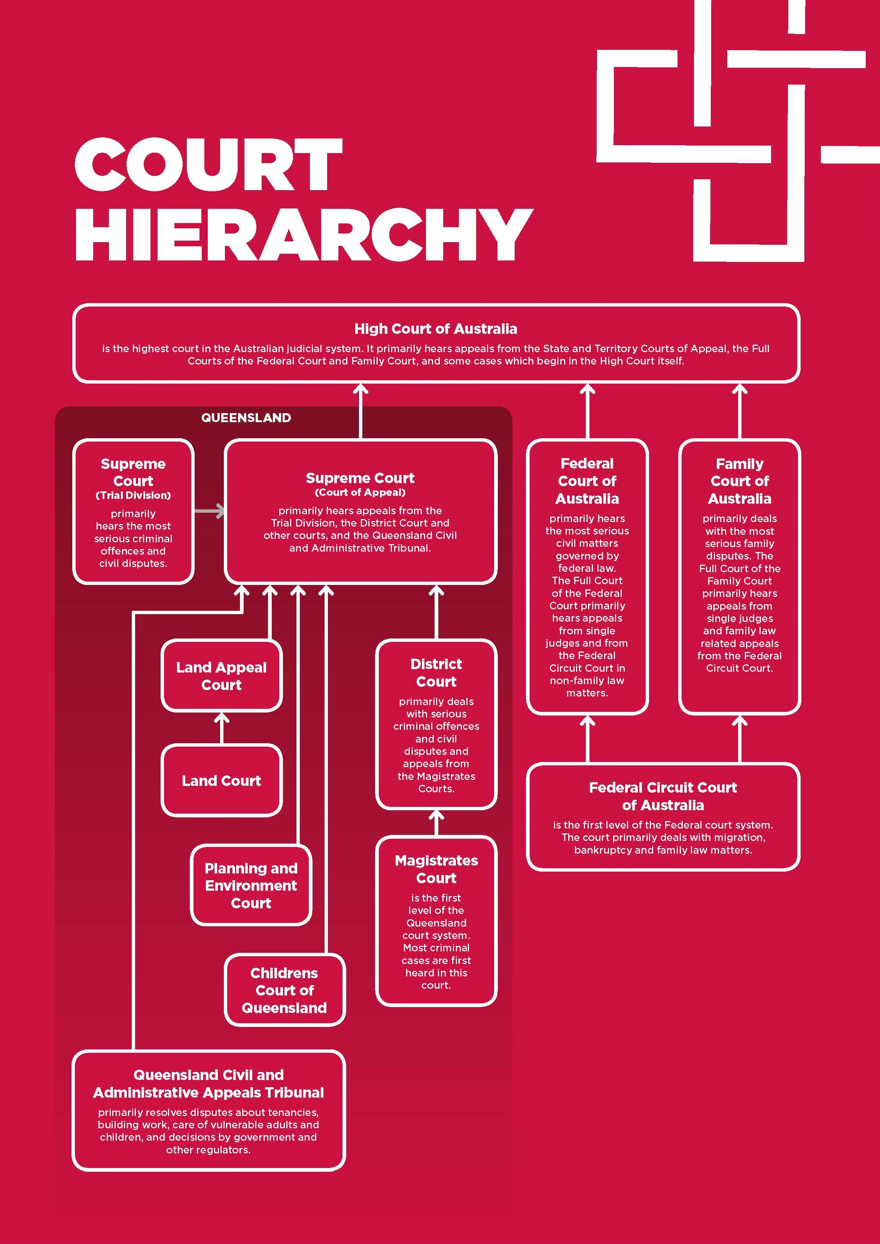
A diagram of the Queensland court hierarchy. This diagram is displayed in the exhibition Without fear or favour: exploring Queensland’s legal system.

Learning activities

- Define the following key terms:

Appeal:
Civil law:
Criminal law:
Doctrine of precedent:
Original jurisdiction:

- Describe the court hierarchy in Queensland as it would apply to a murder trial (including an appeal).

- Match the following types of matters with the correct court jurisdiction:

armed robbery residential tenancy dispute appeal from District Court
manslaughter drink-driving graffiti
building dispute appeal from Magistrates Court stealing
sexual assault drug trafficking shoplifting

- Identify and list the different types of specialised courts that exist in Queensland.

- Create an infographic that explains three advantages of the court hierarchy.

- Identify and explain the different grounds of appeal that may be used by a defendant appealing their conviction in the Queensland Court of Appeal.

- Explain how the court hierarchy facilitates the just and equitable resolution of disputes.

- Locate the judgments listed below on the Supreme Court Library Queensland (SCLQ) website, sclqld.org.au/caselaw. Read the beginning of each judgment and complete the table below:

Citation | What court or tribunal is the case being heard in? | Is the court exercising its original or appellate jurisdiction? | Is it a criminal or civil case? | What is the case (briefly) about?
R v Koani [2018] QCA 272
Creighton v Skull [2012] QCAT 652
Watt v Mahoney [2003] QDC 164
Wagner & Ors v Harbour Radio Pty Ltd & Ors [2018] QSA 201
Gamble v Commissioner of Queensland Police Service [2014] QDC 122

Need help completing the table? All the answers can be found on the first page of a judgment. A lot of the information can be found by reading the catchwords.

